

**Replacement of ER- NOC CLC**

**Performance Testing Approach**

**Version 1.0**

**13 April 2021**

Maveric Systems

© 2021 Maveric Systems. All rights reserved. No part of this document may be reproduced or transmitted in any form or by any means, electronic, mechanical, photocopying, recording, or otherwise, without prior permission from Maveric Systems.

**Reference and Source Documentation**

|  |  |  |  |
| --- | --- | --- | --- |
| **#** | **Document Name** | **Shared By** | **Version** |
| 1 | ER- NOC CLC Performance Testing Strategy | BM IT | V 1.0 |
|  |  |  |  |

**Revision History**

|  |  |  |  |
| --- | --- | --- | --- |
| **Author** | **Date** | **Version** | **Comments** |
| Vimal Raj | 13-Apr-20 | V 0.1 | Baseline version |
|  |  |  |  |
|  |  |  |  |

**Reviewed By**

|  |  |  |  |
| --- | --- | --- | --- |
| **Reviewers** | **Date** | **Version** | **Role** |
|  |  |  |  |

**Approved By**

|  |  |  |  |
| --- | --- | --- | --- |
| **Approvers** | **Date** | **Version** | **Role** |
|  |  |  |  |
|  |  |  |  |
|  |  |  |  |

## 1 Background

Bank Muscat (BM) wishes to develop a new age centralized solution that would reduce the overall operational processes of finance, Cash Management, Locker, Asalah and Najahi and automatically maintain records for all modules in this new solution. In this process, Bank Muscat has planned for Performance testing of the Electronic Replacement NOC CLC Application to report the performance bottlenecks and improve the operational efficiency. Maveric has extended the support to benchmark the Electronic Replacement NOC CLC Application in line to the expectations of BM IT. Please refer the below section for the list of Categories and the respective performance test details.

## 2 Performance Testing

|  |  |
| --- | --- |
| Categories | Performance Test Details |
| Application in Scope | Electronic Replacement NOC CLC |
| Testing Types | * Load/ Volume Test * Stress Test * Endurance Test |
| Test Objective | * To measure the end to end response time while handling 161 concurrent user load |
| * To measure the performance of the Electronic Replacement NOC CLC application under stress condition with 200% of volume |
| * To measure the performance of the Electronic Replacement NOC CLC application while handling 50% user load for a prolonged duration of 6 hours |
| * To monitor the relevant server metrics during execution and ensure the resources utilization are under threshold limits (< 60% utilization) |
| Test Design Approach | * User actions of the workflows under scope will be performed in browser and the network traffic for the same will be captured as scripts using IBM Rational Performance tester tool |
| Test Execution Approach | * The agreed number of user concurrency and volume will be generated with recorded scripts in the network layer and the server response time and server resource utilization metrics will be captured and reported for performance bottlenecks |
| Systems Involved | * iBPS * Only Office * ESB & T24 |
| Test Environment | * UAT Environment * Environment Hardware Sizing – 50% of Production |
| Transactions | Below mentioned area agreed transaction which forms scope for PT Testing,   * NOC Certificate -3000   + Case_Initiation 3000   + Retention Unit Checker 200   + Retention Unit Authorizer 2000   + Doc Generation   + Doc Review * CLC Certificate (Other bank) -100 (2025)   + Case_Initiation   + Retention Unit Checker   + Retention Unit Authorizer   + Doc Generation – Once in a day   + Doc Review * CLC Certificate (Transfer to Meethaq Finance)- 10 (2025)   o Case_Initiation  o Branch Checker  o Doc Generation  o Doc Review  Note:   * The above mentioned transactions are derived based on the ER- NOC CLC Performance Testing Strategy document shared by BM IT and discussed with Business |
| Execution Rounds | * **Round 1 - Sanity Test** (to ensure the stability of the performance test environment) * **Round 2 - Load Test – Individual Load Test**    + **30 % load**     - Cycle 1 - (1 day), Defect fixing (2 day)     - Cycle 2 - Retest (1 day)   + **50 % load**     - Cycle 1 - (1 day), Defect fixing (2 day)     - Cycle 2 - Retest (1 day)   + **100 % load**     - Cycle 1 - (1 day), Defect fixing (2 day)     - Cycle 2 – Retest (1 day) * **Round 3 – Endurance Test**    + **50 % Volume for 5 hours**     - Cycle 1 – (2 day) * **Round 4 – Stress Test**    + **200 % Load**     - Cycle 1 – (2 day) * **Round 6 – Combined Test (CLOS, LOS, Remittance and ER NOC CLC profile)**    + **100% load**     - Cycle 1 – (2 day)   Note:   * There will be 2 cycles for each round of testing to ensure the fixes quality & consistency in the results except for (Stress, Endurance and Combined Test) |
| SLA | From our earlier engagements with Newgen application in BM, following are the types of calls with its respective SLA   * Update calls - 5 to 7 secs * Fetch calls - 3 to 5 secs * Within IBPS calls - 3 secs * Document upload/download calls – 3 secs * Generate document calls – 5 to 8 secs   Note: Detailed SLA for every user action in the business functionalities will be shared before the Test execution activities |
| Defect  Management | * Performance Defect life cycle to be tracked in TFS * The maximum TAT for fixing the performance issues would be **2 days** * The Performance defects will be raised against the performance metrics (Response Time, Resource utilization & throughput) against the respective SLA |
| Monitoring Tool / Utility Tool | * Uptime Resource utilization tool – To be configured by BM IT |
| Schedule | |  |  |  |  |  |  |  |  | | --- | --- | --- | --- | --- | --- | --- | --- | |  | W1 | W2 | W3 | W4 | W5 | W6 | W7 | | Planning and Design |  |  |  |  |  |  |  | | Load Test |  |  | | |  |  |  | | Endurance Test |  |  |  |  |  | 3 |  | | Stress Test |  |  |  |  |  |  |  | | Combined Load Test |  |  |  |  |  |  |  | | Closure |  |  |  |  |  |  |  |     **Note:** The above schedule is derived based on the scope of work. |
| Critical  Assumptions | * The basic performance parameters across the Electronic Replacement NOC CLC server stack for the expected load would be configured by Newgen team prior to the Performance test execution * All the performance tuning & recommendations provided in the earlier engagements should be configured before performance test execution (Request parallelization, configuring adequate no of threads per work item, minifying static files, removing duplicate server calls) * Test design activity will be started once the application is code frozen (No field level or code level changes in the application) * BM IT team to support extracting server logs in order to analyze the performance metrics * Uptime resource monitoring would be made available in the environment finalized for Performance testing * Benchmark and performance test results are subjected to the environment setup * Defect fix turnaround time is considered to be maximum 2 days * PT defect to be managed/ tracked in TFS * SPOC from application team would be made available for fixing performance issues * Performance Testing would be carried out in UAT environment * 200 User credentials and 5500 legal ID’s for existing customers will be shared by BM Team. * Security encryption to be disabled during the scripting and PT execution time * Any deployment in UAT environment to be post discussion with PT Team * There shouldn’t be any showstopper / major functional issues on the finalized performance transactions * There shouldn't be any major functional fixes that affects the performance scripting otherwise it requires additional effort in maintaining the existing scripts/re-scripting |
| Deliverables | |  |  | | --- | --- | | Phases | Performance Deliverables | | Planning | * Test Approach document * Work Load Model | | Execution | * Execution Summary Report at the end of each cycle of testing | | Closure Report | * Final Test Report |   . |
| Out of Scope | * Other applications & transactions apart from the agreed scope will not be performance tested * Other Non-Functional testing including Database testing, Disaster Recovery, Fail-over / Fail Back, High Availability, Usability testing, Security Testing, Network emulation, Data migration testing & Data Integrity Testing of migrated data along with base data volume creation in the database * Any form of functional testing including field level validations, systems testing & integration testing are not in scope * Performance testing in any other environment other than the finalized performance test environment will not be tested * Performance execution will not cover any testing types other than agreed scope (Load /Volume, Stress, Endurance). Also, any Browser UI response time of Electronic Replacement NOC CLC application/ other applications integrated with Electronic Replacement NOC CLC application will not be tested as part of Electronic Replacement NOC CLC Performance Testing |

## 3 Electronic Replacement NOC CLC - Technical Architecture

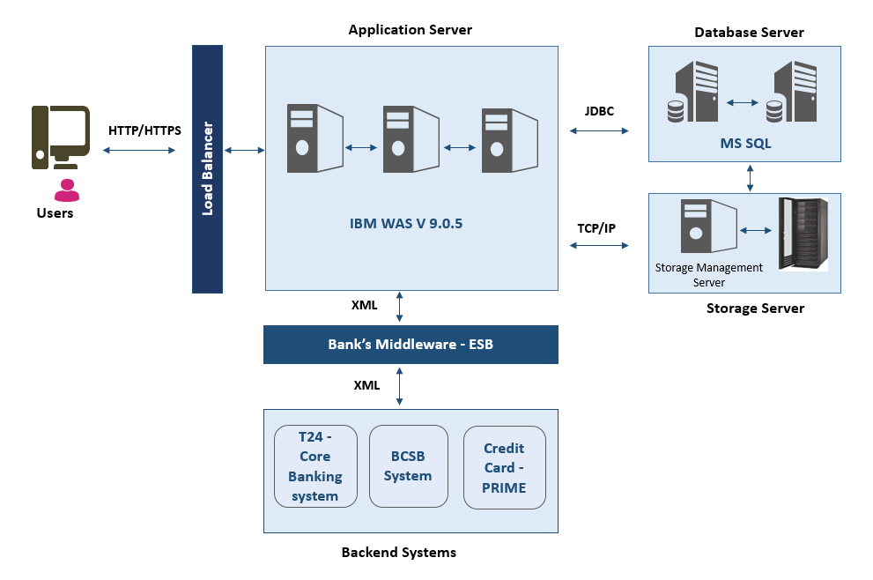

## 4 Environment Details – Production

|  |  |  |  |  |  |  |  |
| --- | --- | --- | --- | --- | --- | --- | --- |
| Hardware | Application Server | | | Image/Utility Server | | DB Server | |
| **App Srv1** | **App Srv2** | **App Srv3** | **ImgSrv1** | **ImgSrv2** | **DB Srv1** | **DB Srv2** |
| Processor | 6 VCPU | 6 VCPU | 4 VCPU | 4 VCPU | 4 VCPU | 6 VCPU | 6 VCPU |
| Hostname | HODCIBPSAPP1 | HODCIBPSAPP2 | HODCIBPSAPP3 | HODCIBPSIMG1 | HODCIBPSIMG2 | HODCIBPSDB1 | HODCIBPSDB2 |
| RAM | 120 GB | 120 GB | 48 GB | 32 GB | 32 GB | 130 GB | 130 GB |
| SAN disks allocated space | 69.8 GB | 69.8 GB | 69.8 GB | 1854 GB | 69.8 GB | 1462 GB | 1177 GB |
| Software | OS: Microsoft Windows Server 2016 WAS: IBM Websphere V 9.0.5 iBPS 4.0 SP1 Java 1.8 | OS: Microsoft Windows Server 2016 WAS: IBM Websphere V 9.0.5 iBPS 4.0 SP1 Java 1.8 | OS: Microsoft Windows Server 2016 WAS: IBM Websphere V 9.0.5 iBPS 4.0 SP1 Java 1.8 | OS: Microsoft Windows Server 2016  WAS: IBM Web sphere 9.0.5 iBPS 4.0 SP1 Java 1.8 | OS: Microsoft Windows Server 2016  WAS: IBM Web sphere 9.0.5 iBPS 4.0 SP1 Java 1.8 | OS: Microsoft Windows Server 2016  DB: Microsoft SQL Server 2017 Java 1.8 | OS: Microsoft Windows Server 2016  DB: Microsoft SQL Server 2017 Java 1.8 |
| Network IP Address | 10.6.xx.xx | 10.6.xx.xx | 10.6.xx.xx | 10.6.xx.xx | 10.6.xx.xx | 10.6.xx.xx | 10.6.xx.xx |

## 5 Environment Details – UAT

|  |  |  |  |  |  |  |  |
| --- | --- | --- | --- | --- | --- | --- | --- |
| Hardware | Application Server | | | Image/Utility Server | | DB Server | |
| **App Srv1** | **App Srv2** | **App Srv3** | **ImgSrv1** | **ImgSrv2** | **DB Srv1** | **DB Srv2** |
| Processor | 4 VCPU | 4 VCPU | 2VCPU | 4 VCPU | 4 VCPU | 4 VCPU | 4 VCPU |
| Hostname | TESTIBPSUATAPP1 | TESTIBPSUATAPP2 | TESTIBPSUATAPP3 | TESTIBPSUATIMG | TESTIBPSUATUTL | TESTNGIBPSDB1 | TESTNGIBPSDB2 |
| RAM | 32GB | 32GB | 16GB | 32 GB | 32 GB | 64 GB | 64 GB |
| SAN disks allocated space | 69.6 GB | 69.6 GB | 69.8 GB | 69.6 GB + 349 GB | 69.6 GB | 1462 GB | 500 GB for Backup |
| Software | OS: Microsoft Windows Server 2016 WAS: IBM Websphere V 9.0.5 iBPS 4.0 SP1 Java 1.8 | OS: Microsoft Windows Server 2016 WAS: IBM Websphere V 9.0.5 iBPS 4.0 SP1 Java 1.8 | OS: Microsoft Windows Server 2016 WAS: IBM Websphere V 9.0.5 iBPS 4.0 SP1 Java 1.8 | OS: Microsoft Windows Server 2016  iBPS 4.0 SP1  Java 1.8 | OS: Microsoft Windows Server 2016  iBPS 4.0 SP1  Java 1.8 | OS: Microsoft Windows Server 2016  DB: Microsoft SQL Server 2017 Java 1.8 | OS: Microsoft Windows Server 2016  DB: Microsoft SQL Server 2017 Java 1.8 |
| Network IP Address | 192.168.xx.xx | 192.168.xx.xx | 192.168.xx.xx | 192.168.xx.xx | 192.168.xx.xx | 192.168.xx.xx | 192.168.xx.xx |